Lincoln’s Gettysburg Address

Four score and seven years ago our fathers brought forth on this continent a new nation, conceived in liberty, and dedicated to the proposition that all men are created equal.
Now we are engaged in a great civil war, testing whether that nation, or any nation, so conceived and so dedicated, can long endure. We are met on a great battle-field of that war. We have come to dedicate a portion of that field, as a final resting place for those who here gave their lives that that nation might live. It is altogether fitting and proper that we should do this.
But, in a larger sense, we can not dedicate, we can not consecrate, we can not hallow this ground. The brave men, living and dead, who struggled here, have consecrated it, far above our poor power to add or detract. The world will little note, nor long remember what we say here, but it can never forget what they did here. It is for us the living, rather, to be dedicated here to the unfinished work which they who fought here have thus far so nobly advanced.
It is rather for us to be here dedicated to the great task remaining before us—that from these honored dead we take increased devotion to that cause for which they gave the last full measure of devotion—that we here highly resolve that these dead shall not have died in vain—that this nation, under God, shall have a new birth of freedom—and that government of the people, by the people, for the people, shall not perish from the earth.
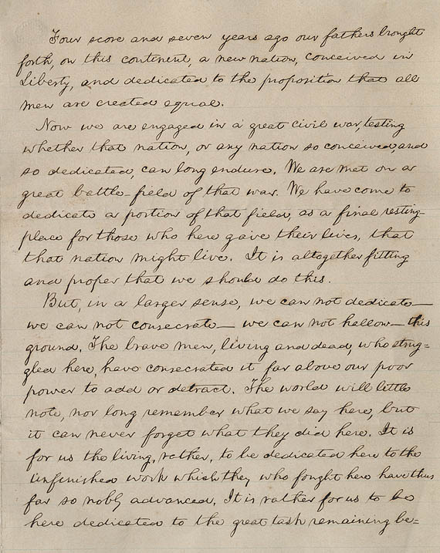

The Emancipation Proclamation
January 1, 1863
By the President of the United States of America: A Proclamation.
Whereas, on the 22nd day of September, in the year of our Lord 1862, a proclamation was issued by the President of the United States, containing, among other things, the following, to wit:
"That on the first day of January, in the year of our Lord one thousand eight hundred and sixty-three, all persons held as slaves within any State or designated part of a State, the people whereof shall then be in rebellion against the United States, shall be then, thenceforward, and forever free; and the Executive Government of the United States, including the military and naval authority thereof, will recognize and maintain the freedom of such persons, and will do no act or acts to repress such persons, or any of them, in any efforts they may make for their actual freedom.
"That the Executive will, on the first day of January aforesaid, by proclamation, designate the States and parts of States, if any, in which the people thereof, respectively, shall then be in rebellion against the United States; and the fact that any State, or the people thereof, shall on that day be, in good faith, represented in the Congress of the United States by members chosen thereto at elections wherein a majority of the qualified voters of such State shall have participated, shall, in the absence of strong countervailing testimony, be deemed conclusive evidence that such State, and the people thereof, are not then in rebellion against the United States."
Now, therefore I, Abraham Lincoln, President of the United States, by virtue of the power in me vested as Commander-in-Chief, of the Army and Navy of the United States in time of actual armed rebellion against the authority and government of the United States, and as a fit and necessary war measure for suppressing said rebellion, do, on this first day of January, in the year of our Lord one thousand eight hundred and sixty-three, and in accordance with my purpose so to do publicly proclaimed for the full period of one hundred days, from the day first above mentioned, order and designate as the States and parts of States wherein the people thereof respectively, are this day in rebellion against the United States, the following, to wit:
Arkansas, Texas, Louisiana, (except the Parishes of St. Bernard, Plaquemines, Jefferson, St. John, St. Charles, St. James Ascension, Assumption, Terrebonne, Lafourche, St. Mary, St. Martin, and Orleans, including the City of New Orleans) Mississippi, Alabama, Florida, Georgia, South Carolina, North Carolina, and Virginia, (except the forty-eight counties designated as West Virginia, and also the counties of Berkley, Accomac, Northampton, Elizabeth City, York, Princess Ann, and Norfolk, including the cities of Norfolk and Portsmouth[)], and which excepted parts, are for the present, left precisely as if this proclamation were not issued.
And by virtue of the power, and for the purpose aforesaid, I do order and declare that all persons held as slaves within said designated States, and parts of States, are, and henceforward shall be free; and that the Executive government of the United States, including the military and naval authorities thereof, will recognize and maintain the freedom of said persons.
And I hereby enjoin upon the people so declared to be free to abstain from all violence, unless in necessary self-defence; and I recommend to them that, in all cases when allowed, they labor faithfully for reasonable wages.
And I further declare and make known, that such persons of suitable condition, will be received into the armed service of the United States to garrison forts, positions, stations, and other places, and to man vessels of all sorts in said service.
And upon this act, sincerely believed to be an act of justice, warranted by the Constitution, upon military necessity, I invoke the considerate judgment of mankind, and the gracious favor of Almighty God.
In witness whereof, I have hereunto set my hand and caused the seal of the United States to be affixed.
Done at the City of Washington, this first day of January, in the year of our Lord one thousand eight hundred and sixty three, and of the Independence of the United States of America the eighty-seventh.
By the President: ABRAHAM LINCOLN
WILLIAM H. SEWARD, Secretary of State.
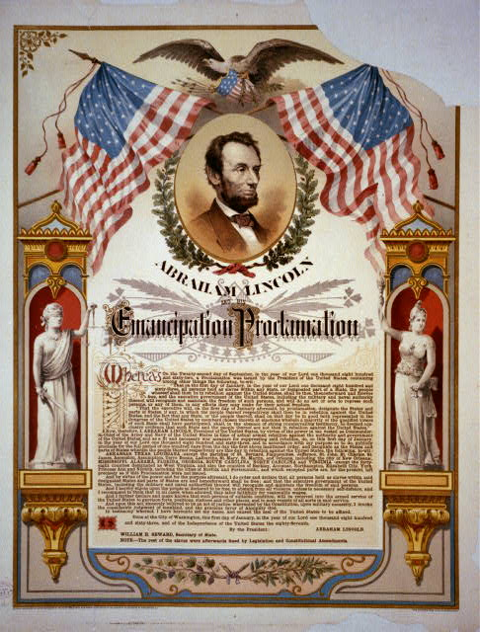
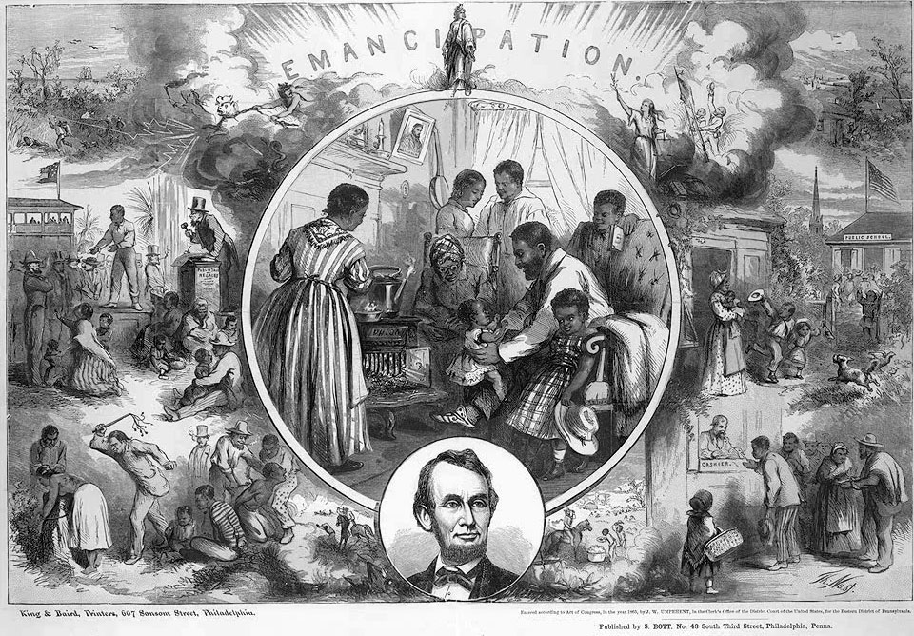
Source I
Source A
“Surprisingly fine as Mr. Everett’s oration was in the Gettysburg consecration, the rhetorical honors of the occasion were won by President Lincoln. His little speech is a perfect gem; deep in feeling, compact in thought and expression, and tasteful and elegant in every word and comma. Then it has the merit of unexpectedness in its verbal perfection and beauty… Turn back and read it over, it will repay study as a model speech. Strong feelings and a large brain are its parents.”
The Springfield Republican
November 20, 1863

Source H
“Readers will not have failed to observe the exceeding bad taste which characterized the remarks of the President . . . at the dedication of the soldier’s cemetery at Gettysburg. The cheek of every American must tingle with shame as he reads the silly, flat, and dish-watery utterances of the man who has to be pointed out to intelligent foreigners as the President of the United States.”
Chicago Times
November 20, 1863

Source D
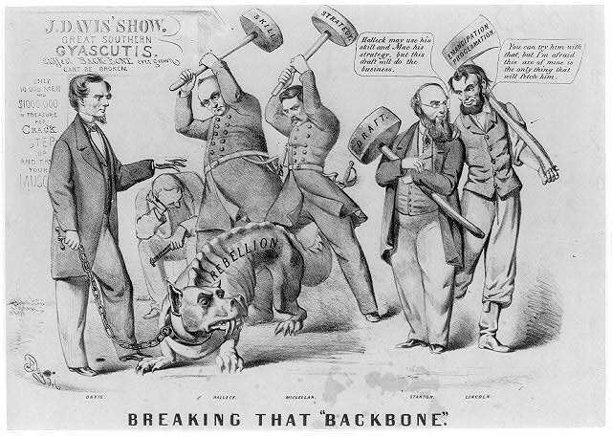

Source G
President Lincoln is a savage" and a fiend! The very ignorance which drives him to his own destruction stimulates him to the darkest excesses. What comes next will be like the Nat Turner massacre in 1831. It is one of the means which the most callous highwayman should shudder to employ. "The hellish new programme will, necessarily, destroy all terms between us. The next campaign will be a tremendous one, both for the character and magnitude of the hostility. Let our authorities prepare the whole strength of our people for a tremendous shock.
The Richmond Enquirer
January 4, 1863
Source F
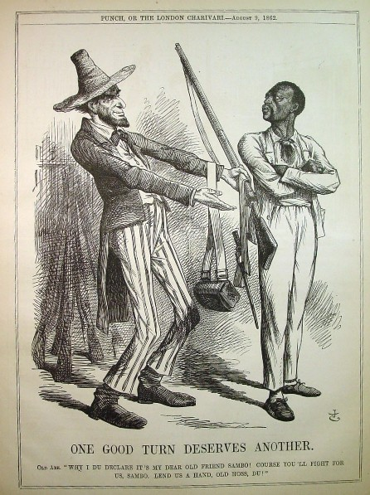

Source E
The President succeeded on this occasion because he acted without sense and without constraint in a panorama that was gotten up more for the benefit of his party than for the glory of the nation and honor of the dead … we pass over the silly remarks of the President: for the credit of the nation we are willing that the veil of oblivion shall be dropped over them and that they shall no more be repeated or thought of.”
Harrisburg Patriot and Union:
November 1863

Source C
In the rebel Senate, Mr. Semmes, of Louisiana, submitted a joint resolution on the proclamation, and said, it was "a gross outrage on the rights of private property and an invitation to servile war, and therefore should be counteracted by such severe retaliatory measures as, in the judgment of the President, may be best calculated to secure its withdrawal or arrest its execution."
Harper’s Weekly
January 6, 1863
Source B
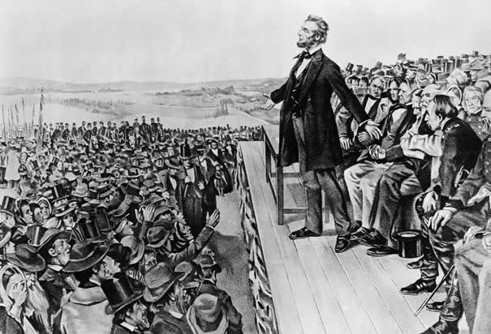
“Lincoln’s Great Speech”
Wherwood Lithograph of Lincoln at Gettysburg

Name _____________________________
Analyzing Abraham Lincoln’s Words
Part I Directions: Read President Lincoln’s “Gettysburg Address” and “Emancipation Proclamation”. Then identify which speech each primary source document refers to and describe the message of the source.

Source | Gettysburg Address or Emancipation Proclamation | Message
A
B
C
D
E
F
G
H
I

After analyzing each of the documents, complete the short answer question on the back of this sheet.
Part II Directions: After reading President Lincoln’s “Gettysburg Address” and “Emancipation Proclamation” and the primary source document reactions to each, which do you feel had a bigger impact on America and why? Be sure to explain your answer using information from the documents.



